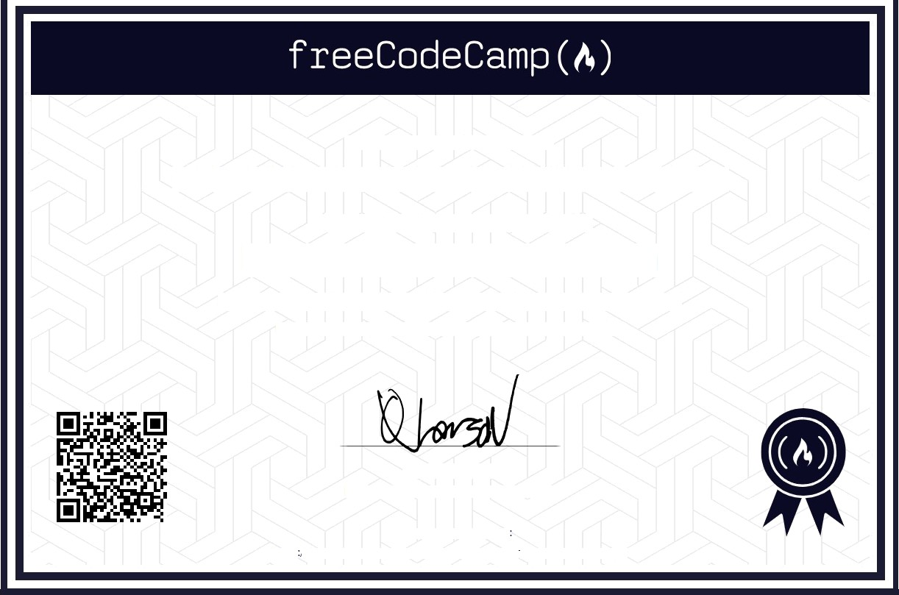

This certifies that

GEDELA HARSHAVARDHAN REDDY
successfully completed the
Responsive web Design
Developer Certification on October 7, 2023
representing approximately 300 hours of work

Quincy Larson
Executive Director, freeCodeCamp.org

Verify this certification at
https://freecodecamp.org/certification/12308190/responsive-web-design

